Report to |  | On | 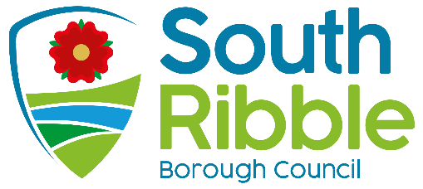
Council |  | 21 July 2021
Title |  | Portfolio Holder |  |  | Report of
Holiday and Food (HAF) Programme Grant 2021 |  | Communities, Social Justice & Wealth Building |  |  | Director of Communities

Is this report confidential? | No

Purpose of the Report
- Members are asked to increase the revenue budget as a result of new external funding for the Holiday and Food Programme, in line with financial regulations.

- South Ribble’s allocation of Holiday and Food (HAF) Grant for 2021 is £225,471.08. Funding comes from the Department for Education, administered by Lancashire County Council. This funding is ringfenced to delivery of a programme of school holiday activities in August and December 2021.

Recommendations
- Council is requested to:
- Approve an increase to the Council’s revenue budget of £225,471.08 to deliver the 2021 HAF Programme.

- Agree that the above funding will be spent in accordance with Department for Education directives; targeting provision of enriching activities and healthy food to children who are in receipt of free school meals,

Reasons for recommendations
- Delivery of a positive activities programme for children supports the Council’s corporate priorities of sustaining thriving communities and healthy places. It complements other schemes such as the holiday hunger programme and school uniform bank; supporting families who need a little additional help.

Other options considered and rejected
- No other options have been considered; this funding is part of a county wide grant with all councils working to a detailed service level agreement.

Corporate outcomes
- The report relates to the following corporate priorities:

An exemplary council |  | Thriving communities
A fair local economy that works for everyone |  | Good homes, green spaces, healthy places

Background to the report
- Lancashire County Council has approached all districts to deliver the Government’s HAF programme for four weeks over the summer holidays and one week at Christmas.

- The programme seeks to offer a range of ‘enriching activities’ and a meal each day to children aged between 4 and 16 who are eligible for free school meals.

Proposals

- Officers are working to create a timetable of activities which will include a range of sports, dance, and arts and crafts events. Schools, parks and community venues have been identified across the borough to support delivery.

- If funding is accepted, the terms of the programme are provision of four hours of activity per day, four days per week, for four weeks in summer holidays and one week at Christmas.

- A food offer is part of the programme, with all children who participate receiving a healthy and balanced meal. Local suppliers will be used to deliver catering services.

Risk
- The risk of declining the funding offer from LCC is that children would miss out on activities and meals which the scheme provides. In addition, there is potential for reputational risk if other Lancashire authorities are running the programme and South Ribble is not.

Equality and diversity
- The HAF Programme is designed nationally to be inclusive and accessible to children in receipt of free school meals.

- An Equality Impact Assessment will be completed as timetable of activities is finalised, however no negative impacts on any of the protected groups are anticipated.

Air quality implications

- Relevant details to be inserted here following liaison with the appropriate Environmental Health Officer.

Comments of the Statutory Finance Officer
- The costs of establishing and delivering the HAF programme for the four week summer holiday period and one week at Christmas, including food provision, will be fully covered by the grant funding offered of £225,471.

Comments of the Monitoring Officer
- There are no concerns from a Monitoring Officer perspective.

Background documents
There are no background papers to this report

Jennifer Mullin
Director of Communities
Report Author: | Email: | Telephone: | Date:
Rebecca Heap | rebecca.heap@southribble.gov.uk | 01772 625276 | 12/7/21

